Michele McCarthy
Presents
Shattered, Stirred and Shaken
Living the Book of Acts: My journey from Here to There
Are you hungry for the bold, power-filled Christian life? Did you know that the “more” you long for is readily available? Your desire to live in the fullness of your inheritance as a child of God opens limitless possibilities. After decades of following Christ, God took me from reading the book of Acts to experiencing Him as the early believers did. Join author Michele McCarthy on an adventure laced with healing, hunger, and humor with a pinch of dignity loss served on the side and step into:

- God’s spiritual, physical, and emotional provision for your life here and now.
- Shattering complacency, timidity, and fear.
- Understanding each spiritual gift accessible to you as sons and daughters.
- Zany God encounters and miracle moments available to you.
Your name is on God’s personal invitation.
“Michele’s journey into the fulness of the Holy Spirit serves as an encouragement to all those who have boldly prayed, “Jesus I want all You have for me.”
—Parkey Cobern, Pastor Capstone Church

About the Author
Michele McCarthy is an award winning children’s author, teacher, and speaker. Shattered, Stirred and Shaken is a Blue Ridge Mountain Writers award winner. She is an Advanced Writers and Speakers Association member as well as a co-founder of Living Write Texas. Her passion is to help others find the destiny God has for them to live fully with the empowerment of God’s gifts.
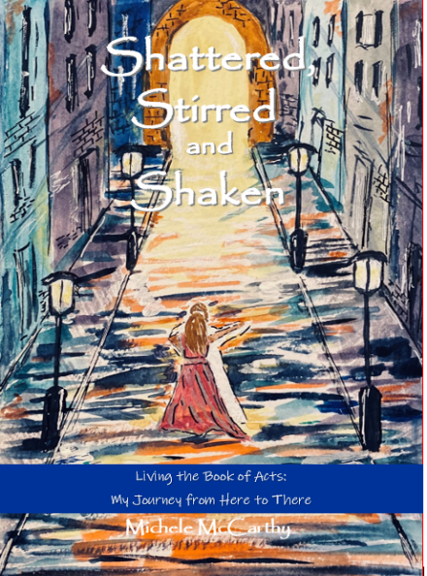

Shattered, Stirred and Shaken
Living the Book of Acts: My Journey from Here to There
Michele McCarthy

978-1-63769-118-2
Paperback $12.99 182pp.
Available: Ingram/Spring Arbor

Michele McCarthy
MicheleMcCarthyBooks.com
MicheleMcCarthyBooks@gmail.com

