Michele McCarthy
Presents
Aunt Ida Clare

Rosalina is not quite sure what to think of their new babysitter, her Aunt Ida Clare. Aunt Ida is quite the sight. Aunt Ida Clare declares the truth and purpose behind speaking life giving words to an unsuspecting brother and sister when she whips out her shiny little object. She is positively the best thing to happen to these impressionable children one school day afternoon.
​“A kind of Cat in the Hat and Mary Poppins rolled together in a very delightful way. Children will adore Aunt Ida Clare.”
—Chris S. Manion

About the Author

Michele McCarthy is an award winning author, teacher, and speaker. She is an Advanced Writers and Speakers Association member as well as a co-founder of Living Write Texas. With a dose of humor and fun, her passion is to help children see themselves the way God sees them.
Suggested interview Questions:

- When did you begin writing children’s books?
- Do you have other children’s books?
- Where did you come up with the idea of Aunt Ida Clare?
- Is your message for children only?
- What is the take-away you want for children and parents who read Aunt Ida Clare?
- Do you have plans for another book in the future?

Be on the lookout for Aunt Ima Mazing
Early 2022

Your text here
Your text here

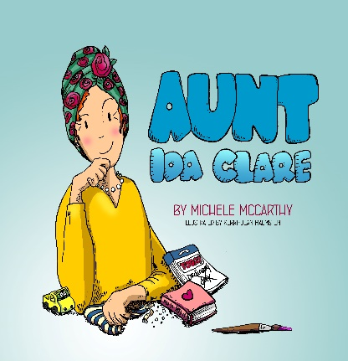

Aunt Ida Clare
Michele McCarthy
978-1-64949-069-8 Hardback $20.00
978-1-64949-068-1 Softcover $10.00
Elk Lake Publisher
Available from Ingram

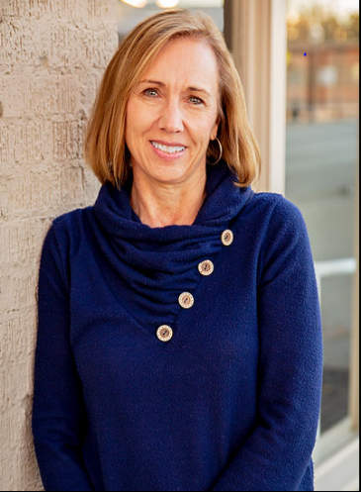

Michele McCarthy
MicheleMcCarthyBooks.com
Look for
Aunt Ima Mazing; Winter 2022
t
michelemccarthybooks@gmail.com

